| <PROJECT NAME> Executive Summary |
| --- |
| Group Member Names2810ICT Software TechnologiesDate |

# Abstract

A 100 to 150 word executive summary of your findings. Do this last.

# Introduction

This report describes the software that has been produced so that users can get information about all the houses in Sydney, so they can easily find the different types of houses they need within a specified time period. They will see the distribution of property prices through graphs, and they can also choose the type of their needs through searches and other customer reviews. Therefore, our team judged and imported the database before making the software, and tested the input empty file and function, then displayed the result, and finally tested the wrong input and the content displayed by the data and chart. After that we tested the software. We first tested the date entered by the customer and displayed the result and the price. By concatenating the csv file, we could use a print report to display the rental price for the date the customer selected. Within the time period entered by the user, connecting the csv file will filter all house prices in this time period and reflect it in the form of a chart, allowing users to see the prices of different houses more intuitively. Then we tested to display the prices of different houses on the selected date. In this file, we use the input function to enter the start date. By concatenating the csv file, we can get the selected date and the price of the house on that day. Then, we tested the start date, end date, and keywords entered by the customer, and displayed the results by id. In this file, by linking the csv file, we use a print statement to show the house that has the keyword in description of the chosen date by the customer. By searching for keywords, such as swimming pools, whether you can bring pets or children, etc. Users can know which houses are suitable for living and which are not. Finally, we tested the cleanliness of the houses that users were most concerned about, and showed the cleanliness of the houses in the comments. In this file, users can use the word "clean" to judge the number of other users who are satisfied with different houses.Within the time period entered by the user, connecting the csv file will filter all house prices in this time period and reflect it in the form of a chart, allowing users to see the prices of different houses more intuitively .By searching for keywords, such as swimming pools, whether you can bring pets or children, etc. Users can know which houses are suitable for living and which are not. Users can browse the popularity of the listings by the cleanliness. We sort them in descending order according to the number of clicks on the listings, so that users can easily know the most popular listings and make it easier for them to choose. Although the functions of our software may not be very detailed, it is definitely suitable for people of all ages, so that they can more easily choose the environment they want to live in when traveling, which not only saves time, but also saves cost.

# **Analysis 1 <**Price of each date**>**

According to the results data of the Assignment1.py, in the 12 month date period, the most expensive renting price was recorded on December 31, 2018, with the id 1366224 for 7500 dollars. The cheapest renting price is 14 dollars, the house id is 4396793. The total number of the cheapest date is 55 days. The result in python is the price per day, as shown below:

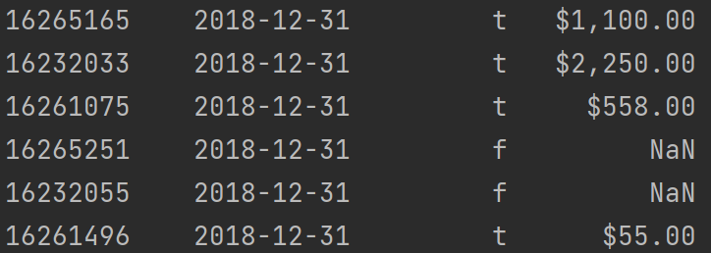

On December 31, 2018, the id 16265251 and 16232055 have no price on this day but the 16265165 has a price which is 1100 dollars. The 16232033 has a price which is 2250 dollars. The 16261075 has a price which is 558 dollars. The 16261496 has a price which is 55 dollars.

# **Analysis 2 <**Bar chart of price**>**

According to the results data of the Assignment2.py, in the 12 month date period, the price of different houses on the same dates will be shown by a bar chart. For example, let’s select December 31, 2018, the The bar will shown below:

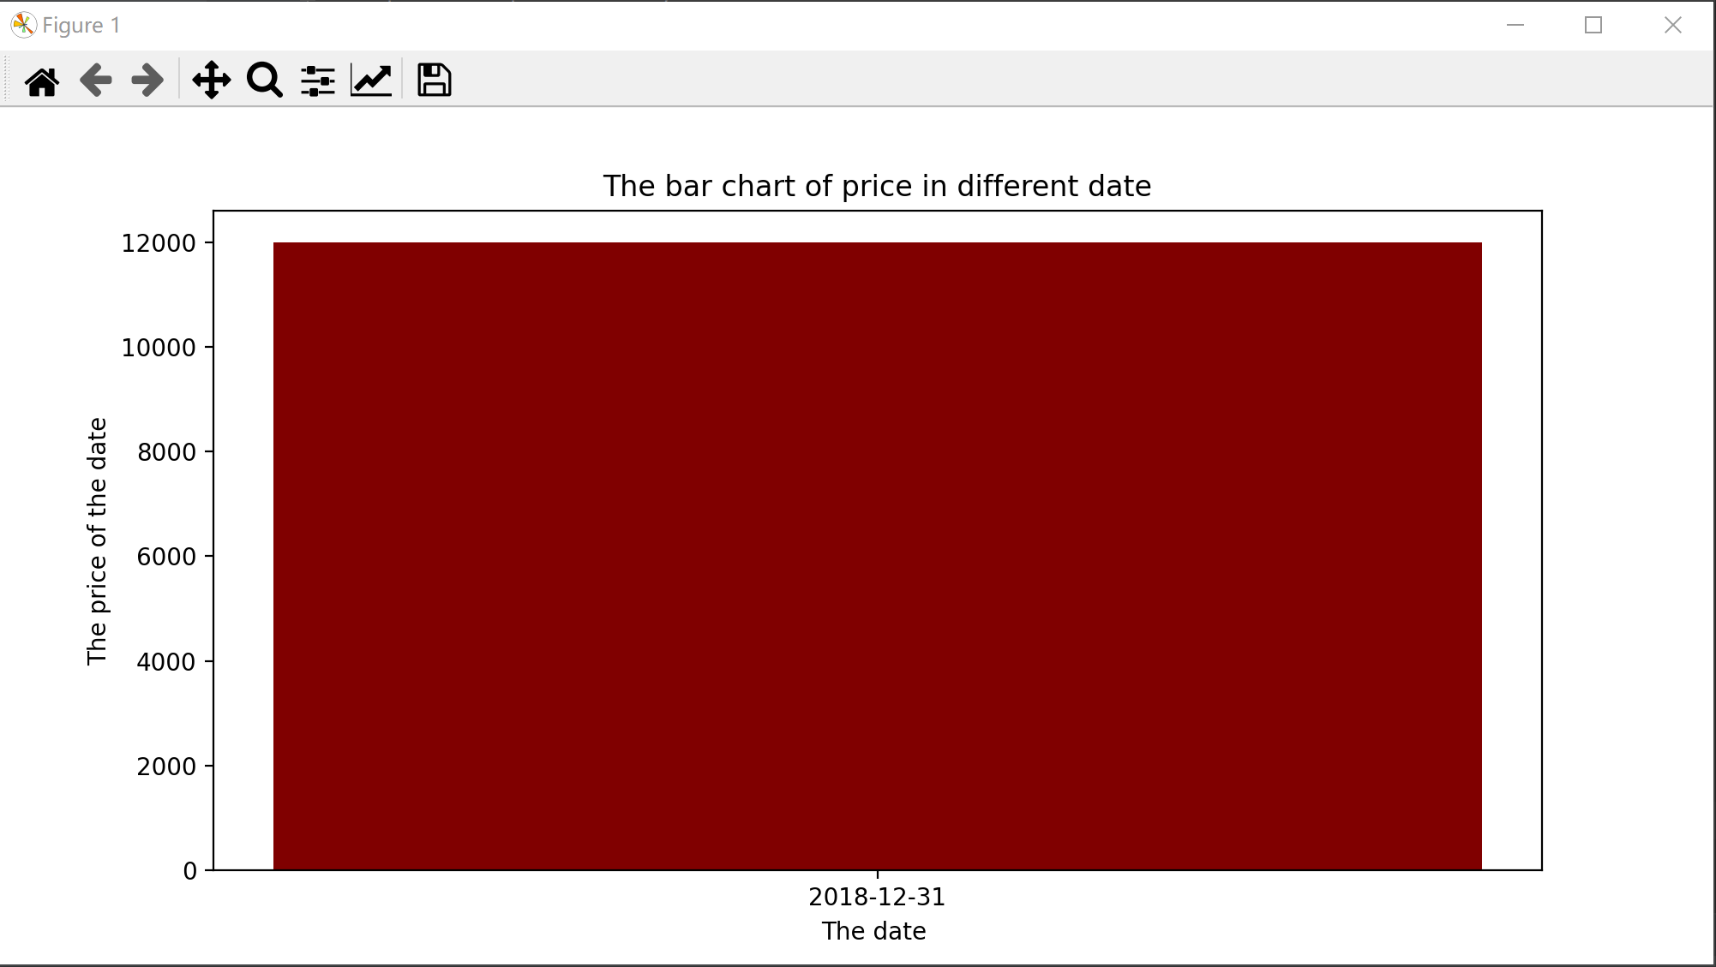

# **Analysis 3 <**Keywords in description**>**

According to the results data of the Assignment3.py, in the 12 month date period, if the house got the keywords in description, it will show true which means that the house got this condition. For example, if we want a house that allows 2 kids with a select date. The console will show the results. The chart will show below:

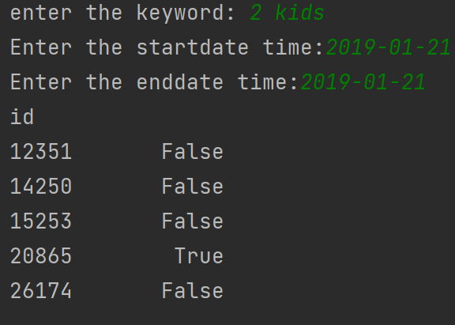

# **Analysis 4 <**The cleanliness of house**>**

According to the results data of the Assignment4.py, true is displayed if the comment column in the data contains a word about tidiness. The results chart will show below:

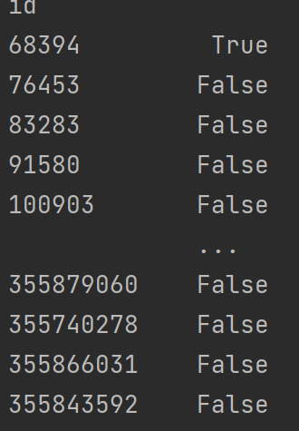

In this chart, we can see the 68394 house got clean mark and house 76453, 83283, 91580 have no this condition in comments.

# **Analysis 5 <Add context to this title>**

According to the results data of the Assignment5.py, in the 12 month date period,

Based on the requirements of your dataset, put the results of your analysis of a 12 month date period for each of the required functionalities in these sections. Change the title names to reflect your dataset and the analysis being performed. You may include images from your program as well as your own description of the results.